Create Microsoft BOT using nodejs

Install VS code and node on your local system

Links : <https://nodejs.org/en/download/>

<https://code.visualstudio.com/Download>

Open power shell and install below with admin privilege

1. npm install –g windows-build-tools

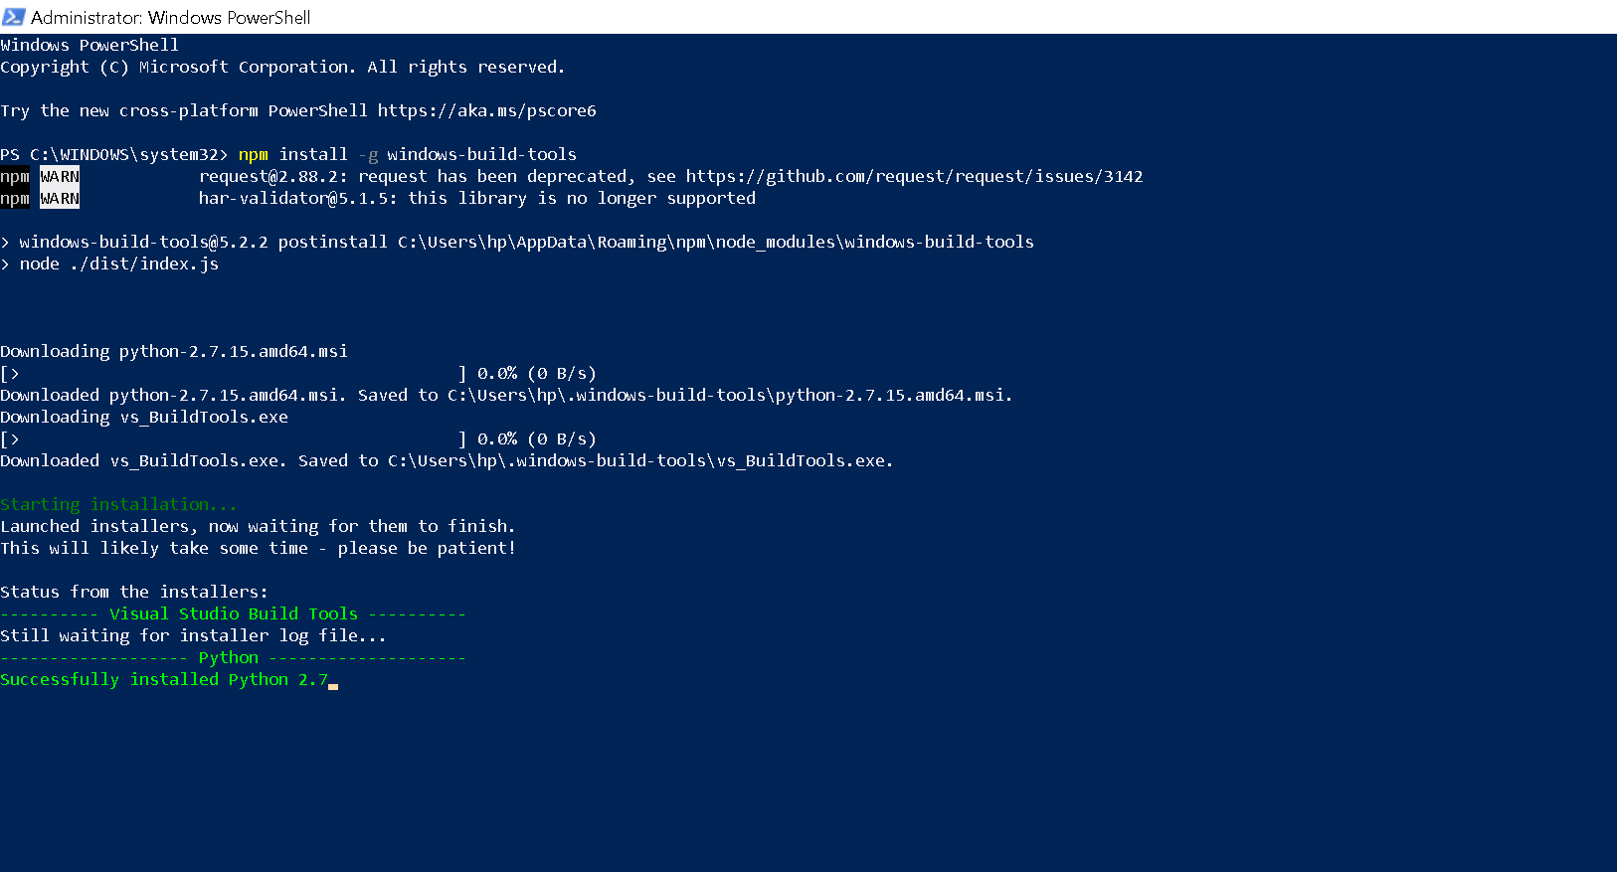

1. Create new folder for your application(MyBot) and install below command

npm install -g yo generator-botbuilder

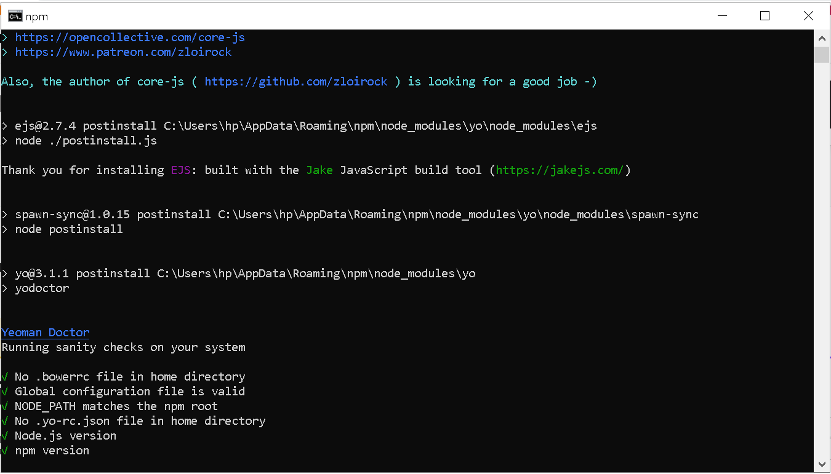

Description : <https://www.npmjs.com/package/generator-botbuilder>

| **Template** | **Description** |
| --- | --- |
| Echo Bot | A good template if you want a little more than "Hello World!", but not much more. This template handles the very basics of sending messages to a bot, and having the bot process the messages by repeating them back to the user. This template produces a bot that simply "echoes" back to the user anything the user says to the bot. |
| Core Bot | Our most advanced template, the Core template provides 6 core features every bot is likely to have. This template covers the core features of a Conversational-AI bot using [LUIS](https://www.luis.ai/). See the **Core Bot Features** table below for more details. |
| Empty Bot | A good template if you are familiar with Bot Framework v4, and simply want a basic skeleton project. Also a good option if you want to take sample code from the documentation and paste it into a minimal bot in order to learn. |

Create BOT Builder through command Prompt -> Go to project folder you created in my case Ashish_Study

>> yo botbuilder

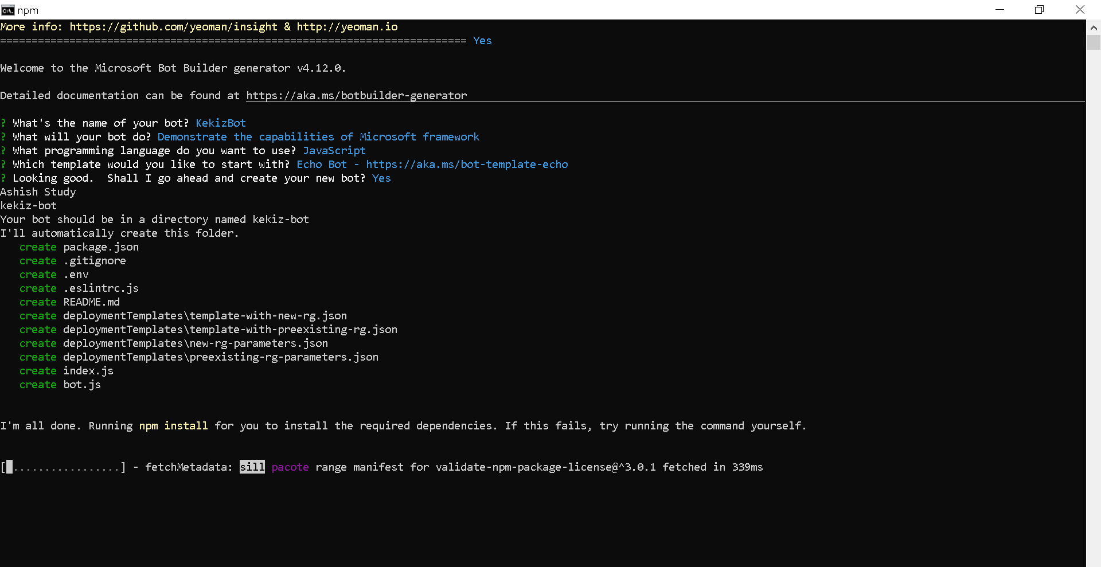

Test and Debug BOT using BOT emulator

<https://github.com/microsoft/BotFramework-Emulator>

<https://github.com/Microsoft/BotFramework-Emulator/releases/tag/v4.13.0>

Next start your application -> Open Bot in VS code -> Open terminal -> Execute below command

>> node index.js

